# Great Yarmouth Economy:

**Employment/Unemployment:** The employment in Great Yarmouth fluctuates thorough the year with a high peak in the summer time when tourism is the main source as income.

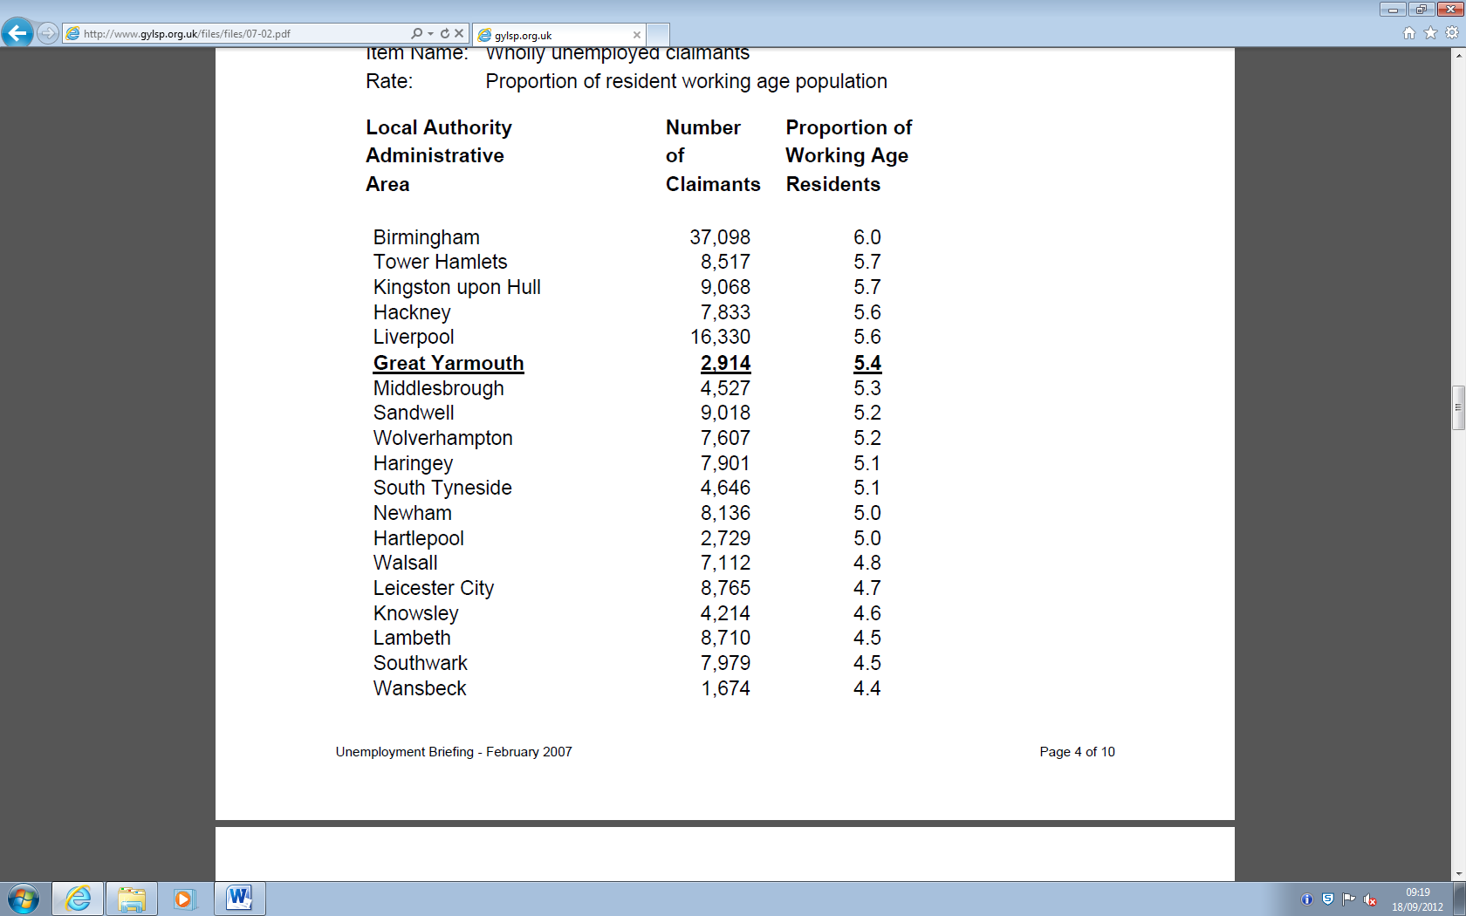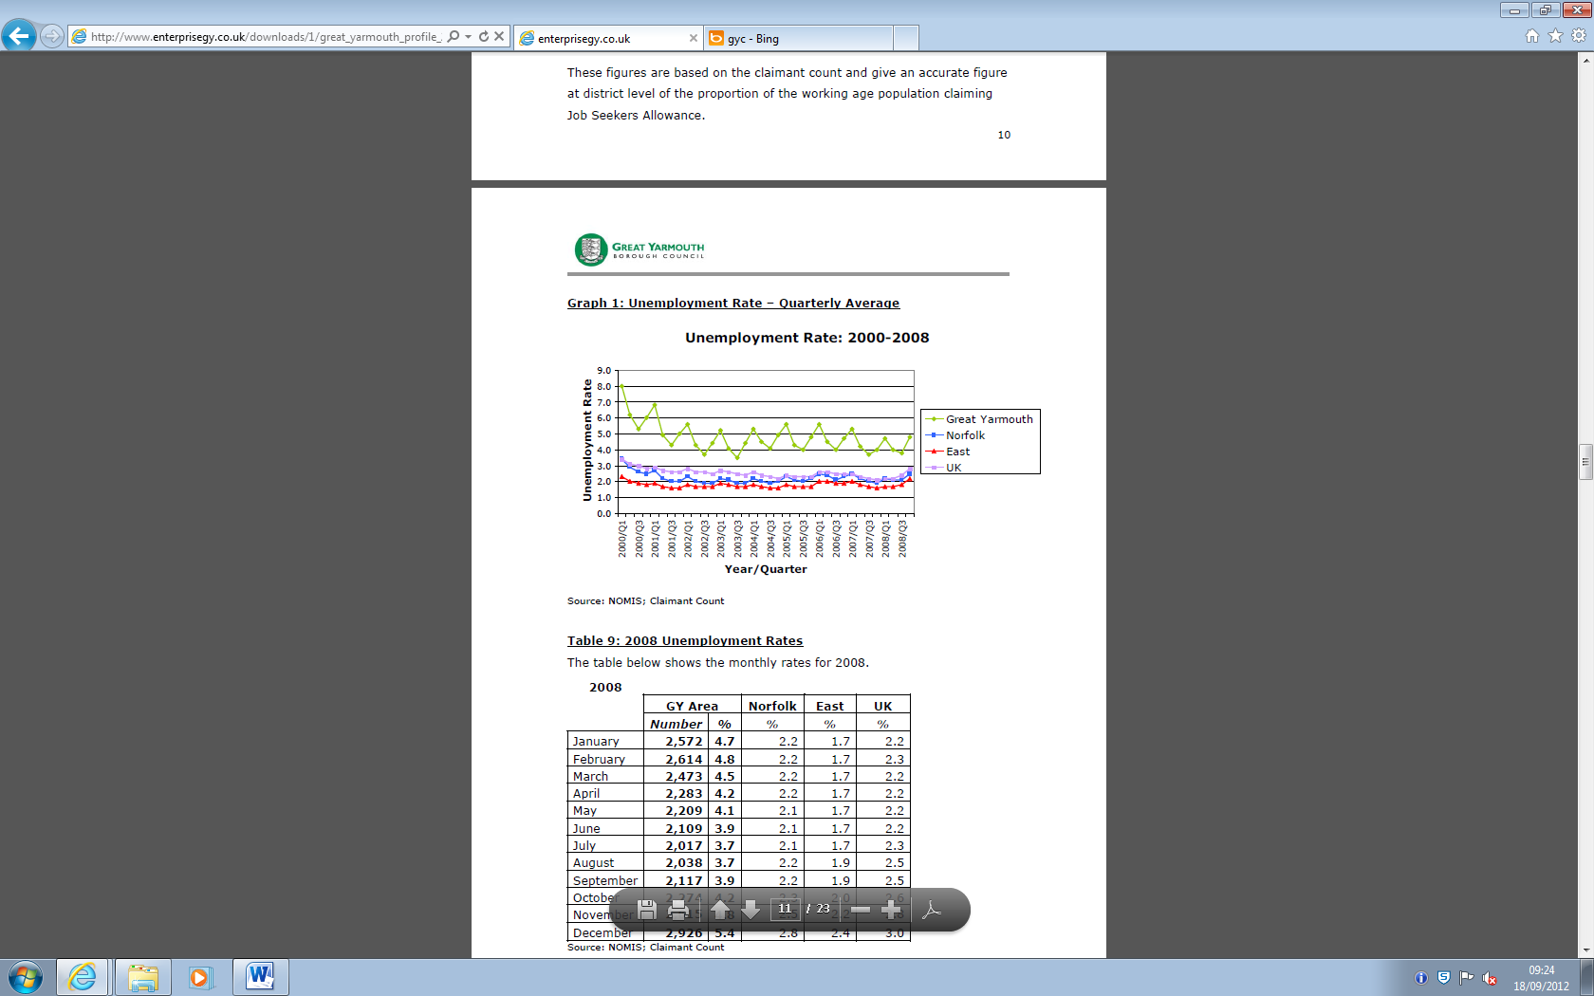

**Primary Sector:**

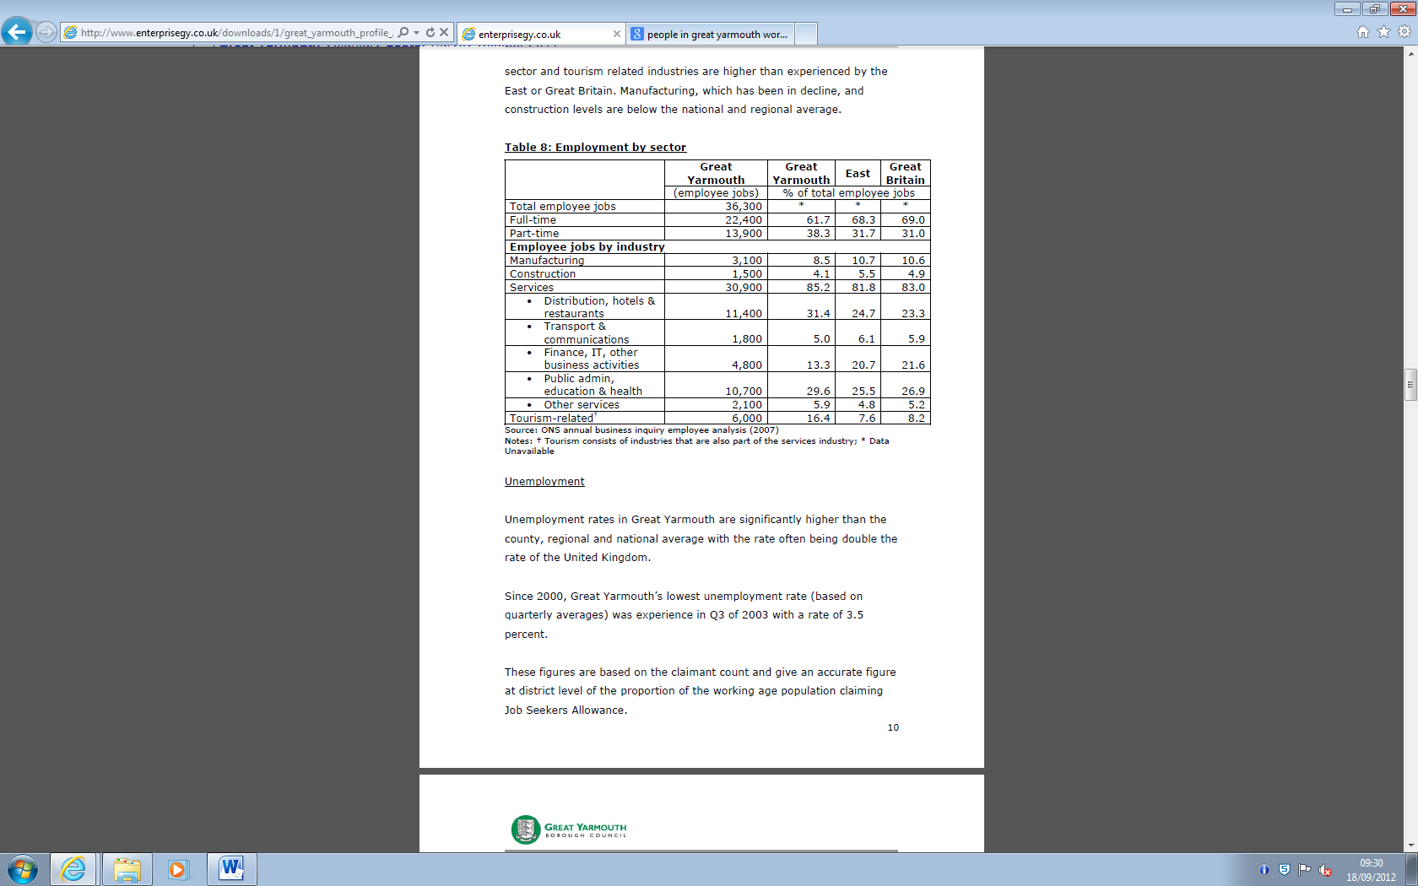

The primary sector is on the rise as there are wind farms being built off the coast of Great Yarmouth, this created many new job opportunities for the residents as there are big plans to expand and improve in this sector. Compared with 100 years ago when animal farms where the major money producers in Great Yarmouth.

**Secondary Sector:**

The secondary sector is very strong in the electronics industry with many major electronics companies based here because of the harbour. Compared with 100 years ago where the

**Tertiary Sector:**

The tertiary sector is strong during the summer as tourism is at its peak in the holidays. Compared with 100 years ago when it was also tourism but now we have more modes of transport so more people can come.

**Sectors that are growing:**

Some elements in the primary sector are growing, such as the wind farm as they are building wind turbines and basing all of the projects in the local area.

**Sectors that are declining:**

Some elements of the primary sector are on the decline such as the fishing industry as the fish are being overfished and the big fishing companies are cheaper than the local fishermen.

Large developments/projects:

The primary sector is developing as we have recently had a wind farm installed on the coast of great Yarmouth; this means we need more houses for the workers, schools for their children and more shops.

**Opportunities:**

Although in Great Yarmouth there are not many employment opportunities, in the surrounding areas there are some of the major businesses. Eg: In Norwich they have Aviva UK General Insurance which is looking for employers. In Bacton they have Perenco UK and in Diss they have Midwich.